NEUROKIDS - After images activity

Instructions:

- On one piece of white paper chose a shape to draw.
- Draw this shape with a bright coloured outline e.g., blue or green and colour in the inside of the shape in a different bright colour e.g., yellow or red.
- Draw a black dot right in the middle of your drawing.
- place a plain white piece of paper next to your drawing or you can use the white space next to your drawing.
- Stare at the black dot in the middle of your drawing for 15-30 seconds.
- Then stare at a blank white space of paper.
- What happened when you started to stare at the plain white piece of paper? Write down what you noticed.
Don’t forget to let us know the results of your experiment…you can add your observation or ask questions here:
https://padlet.com/neurokids/o0dwurxuggsl2g19

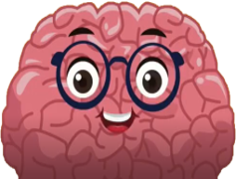

Fact file:
The structure of our eyes

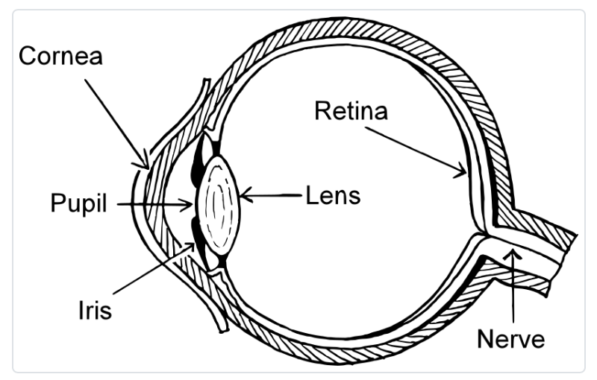

At the back of your eyes is an area called the retina- this is filled with special cells called rods and cones.

These rod and cone cells are light sensitive.

The cones are responsible for seeing colour, and are most sensitive to red, blue and green.

When you stare at your coloured image the cone cells are responsible for allowing you to see these colours.

When you stare at a coloured image for a long time (like in this activity) your cone cells get tired.

This is why you see different colours when you look at the blank piece of paper- the cones are not working as well.

