NEUROKIDS: Pipe Cleaner Neurones

Instructions:

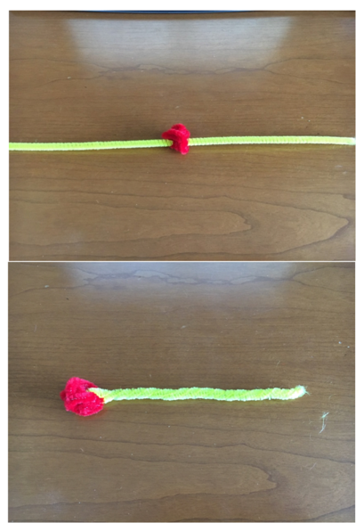
- Take a pipe cleaner and twist or roll it into a ball- this will be the cell body.

- Take a second pipe cleaner and push it through the ball you made in step 1.

- Take the 2 halves of the straight pipe cleaner and twist them together- this is the axon.

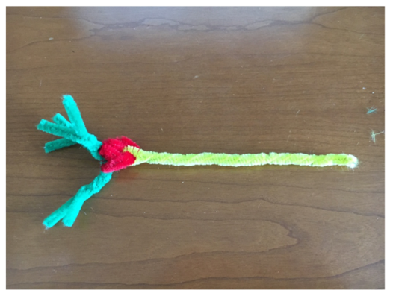
- Take some more pipe cleaners and push them through the other end of the ‘cell body’ to make dendrites.

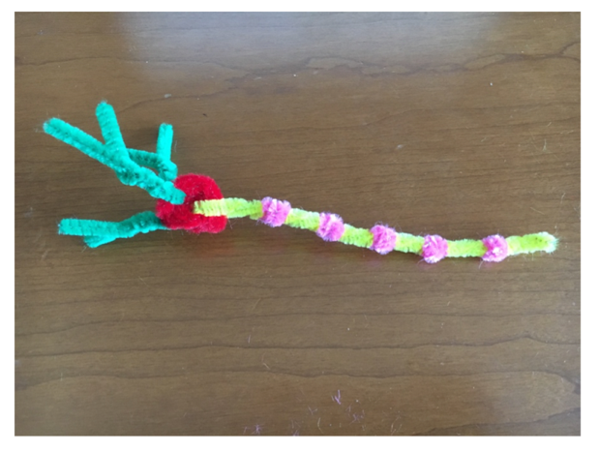
- Wrap small pipe cleaners along the ‘axon’.

- Take one last pipe cleaner and wrap it around the end of the ‘axon’ to make the axon terminal.
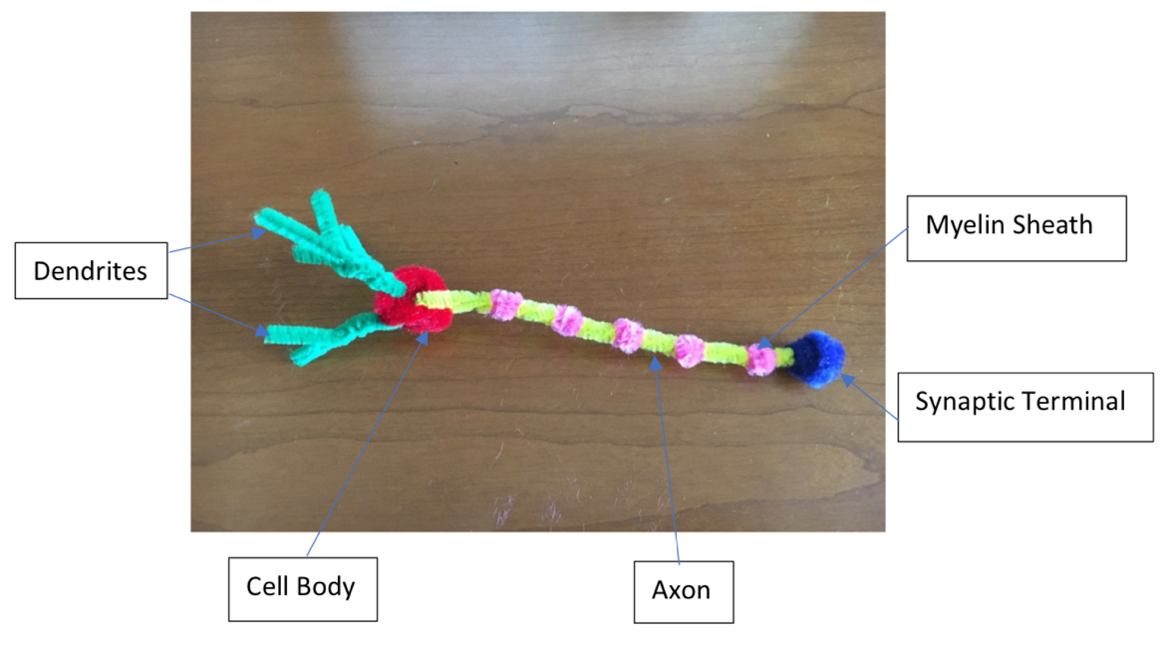

Fact File-
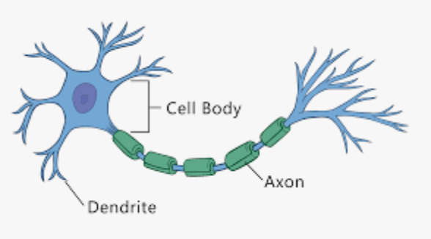
The structure of a neurone:
Neurones have a:
Cell body- containing the nucleus
Dendrites- which extend to other neurons to receive messages
Axon- passes the electrical messages along the neurone

Neurones are specialised cells found all over your body.

They communicate with each other using electrical and chemical messages.

They transmit this information to other nerve cells, glands and muscles.

Axons can range in length from a tiny fraction of an inch to three feet (about one meter) or more!

There are around 100 billion neurons in the human brain!

