NEUROKIDS: Hi, I am BRIAN....

Learn about the structure of the brain

Instructions: The brain hat

Fact File-
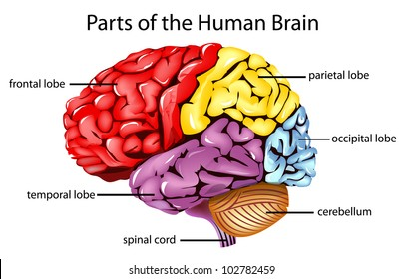

Fun Facts!

Your brain produces enough electricity to power a lightbulb. You might have seen cartoons where lightbulbs pop up above someone’s head to show that they have had an idea.
Well, your brain could actually light up a lightbulb!

The brain is 80% liquid. This is why we have to drink lots of water. If we get dehydrated, our brains don’t work as well.

The brain is divided into two halves, called hemispheres.

The left side of the brain controls the right side of the body, and vice versa. If you are left-handed, it’s the right side of your brain that is in charge.

Every time you learn something new, your brain changes its structure. This is because of the neurons forming new pathways to make accessing and using the new information faster and easier.

The more you learn the more wrinkly the outside of your brain gets. There are more folds on the outside of our brain than other animals, as we are a more intelligent species.

