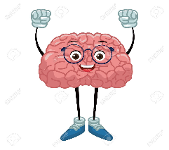NEUROKIDS #2: Hi, I am BRIAN.... explore how I control your body

Hi, thank you for checking out NEUROKIDS!
I hope you enjoyed the video about Brian, and I hope you are having fun at SOTSEF this year.
We thought we would give you some ideas for fun activities you can do at home or in school, so you can learn more about the brain...I mean Brian.
We would love to hear from you and see pictures of what you have been up to during SOTSEF.
Here are some activities you can do to keep you busy:
- Make a brain Hat: check out the instruction “Brain Hat”, you can print them or why not draw your own hat?
- Why don’t you try to bake a cake and make it look like the brain? Make sure it is soft and wrinkly 😊. Take a picture and send it to us, we would love to see your creations!
- Have a go at playing this fun game: “Say the colour of each word”. How fast can you say it? Make sure you tell us!
- If you feel very creative, you can have a go at writing a story or drawing a picture using these sentences:
- My brain helps me_________
- I keep my brain healthy by___________
- My favourite part of the brain is_________because________

We would love to see what you have been up to, if you would like to send us your pictures or poems, send them to us via email at neurokids@soton.ac.uk or you can post here: https://padlet.com/neurokids/o0dwurxuggsl2g19

Thank you
Brian and the NEUROKIDS team

